Pattern 1: Memento Pattern

**Location of the pattern:**

ganttproject/src/main/java/net/sourceforge/ganttproject/undo:

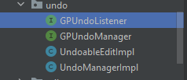

ganttproject/src/main/java/net/sourceforge/ganttproject/undo/UndoableEditImpl.java:

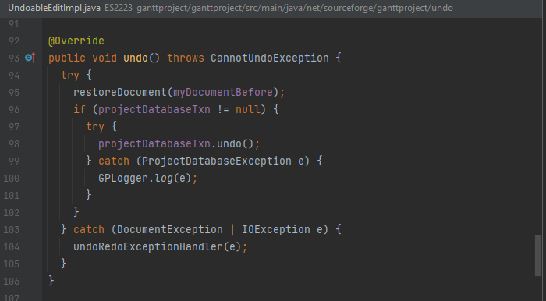

ganttproject/src/main/java/net/sourceforge/ganttproject/GanttProjectBase.java:

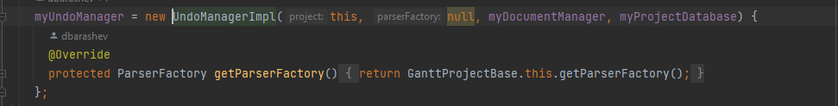

**Explanation:**

This set of classes and interfaces all work together in order to give the user the possibility of undoing edits in the Gantt Project. Undoing an edit is the same as returning the Gantt Chart object to one of its previous  states. This is a characteristic of the Memento Pattern.